SELF- LEARNING SNAKE GAME

( USING DEEP LEARNING )

A Project Report submitted in partial fulfillment of the requirements for the award of the degree of

BACHELOR OF TECHNOLOGY

IN

COMPUTER SCIENCE AND ENGINEERING

Submitted by

S Sravya, 1210315044
Kamshetty Rohith, 1210315018
Komatineni Dileep Kumar, 1210315022
Kadiri Venkat, 1210315016

Under the esteemed guidance of

Mrs. M Bhavani

Asst Professor, Dept of IT



DEPARTMENT OFCOMPUTER SCIENCE & ENGINEERING

GITAM

(Deemed to be University)

VISAKHAPATNAM

April, 2019

DEPARTMENT OF COMPUTER SCIENCE AND ENGINEERING GITAM INSTITUTE OF TECHNOLOGY GITAM

(Deemed to be University)

DECLARATION

I/We, hereby declare that the project report entitled “SELF-LEARNING SNAKE GAME, USING DEEP LEARNING” is an original work done in the Department of Computer Science and Engineering, GITAM Institute of Technology, GITAM (Deemed to be University) submitted in partial fulfillment of the requirements for the award of the degree of B.Tech. in Computer Science and Engineering. The work has not been submitted to any other college or University for the award of any degree or diploma.

Date:

Registration No(s). Name(s) Signature(s)

1210315044 S Sravya
1210315018 Kamshetty Rohith
1210315022 Komatineni Dileep Kumar
1210315016 Kadiri Venkat

DEPARTMENT OF COMPUTER SCIENCE AND ENGINEERING GITAM INSTITUTE OF TECHNOLOGY GITAM

(Deemed to be University)

CERTIFICATE

This is to certify that the project report entitled “SELF-LEARNING SNAKE GAME, USING DEEP LEARNING” is a bonafide record of work carried out by S Sravya (1210315044), Kamshetty Rohith (1210315018), Komatineni Dileep Kumar (1210315022) and Kadiri Venkat (1210315016) students submitted in partial fulfillment of requirement for the award of degree of Bachelors of Technology in Computer Science and Engineering.

Project Guide Head of the Department

Mrs. M Bhavani Dr. K. Thammi Reddy

Assistant Professor Professor
(Dept. Of IT)

ACKNOWLEDGEMENT

We sincerely express our deep sense of gratitude to our guide Mrs M Bhavani, Assistant Professor, Department of Information Technology, GITAM Deemed to be University, for her perspicacity, wisdom and sagacity coupled with compassion and patience. It is our great pleasure to submit this work under his wing.

We are thankful to the teaching and non-teaching staff of the Department of computer science engineering, GITAM Deemed to be University for their inexpressible support. Our sincere thanks to Professor Dr K. Thammi Reddy, Head of the Department, Department of computer science engineering, GITAM Deemed to be University for his kind support in the successful completion of this work.

We are greatly indebted to professor K. Lakshmi Prasad, Principal, GITAM Institute of Technology, GITAM Deemed to be University for providing facilities to carry out this work.

We would like to thank our friends and family members for their valuable co-operation.

TABLE OF CONTENTS
1. | Abstract |  | Page Number
2. | Introduction |  | Page Number
3. | Literature Review |  | Page Number
4. | Problem Identification & Objectives |  | Page Number
5. | System Methodology |  | Page Number
6. | Overview of Technologies |  | Page Number
7. | Implementation |  | Page Number
 | 8.1 | Coding | Page Number
 | 8.2 | Testing | Page Number
8. | Results & Discussions |  | Page Number
9. | Conclusion & Future Scope |  | Page Number
10. | References |  | Page Number

- ABSTRACT

We present a deep learning model for playing snake game with high level input using reinforcement learning. The game is action limited. The model consists of convolution neural network for processing image inputs and fully connected layers for estimating actions according to the inputs where the idea of taking action is based on Q-learning (model-free reinforcement learning), yet modified it for our policy and usage. We applied our method on the python’s ‘PyGame Learning Environment’. We found our method learns fast enough and produced good performance in terms of the learning speed and accuracy.

- INTRODUCTION

Solving games is considered interesting as well as the basis of problem solving structure because of the hostile, competitive challenges and agents involving the environment. Thus, developing a game AI opens the path of implementing the problem-solving ideas in real life situations. Beside that deep reinforcement learning has achieved several high-profile successes in difficult decision-making problems. But these algorithms typically require a huge amount of data before they reach reasonable performance.

In case of hard-coded bots we do not need these data for making the right move for right situations. Most cases the coded bots use greedy search algorithms for finding the best move possible for a particular state. As an example, in snake’s game a bot will try to avoid the walls and find the shortest path for the reward (an apple or a worm). So how can we make a bot understand the same thing by not telling them about the environment, like what the wall is or worm is, just giving them the feedback of what they are doing, which is our way for solving the self-learning feature, using the deep Q learning.

Our challenge is to make that huge amount of data before the learning process actually began. To solve that issue we can use many approaches like watching the replay of pro players for that game or we can feed some random data or we can play for real and record the actions taken for each screen. However, all of these are time consuming as well as requires previous knowledge which we are trying to avoid because of the feature we are talking about “self-learning”.

Another challenge is extracting rewards for each game or choosing the right rewards to improve the game play of the bot. The rewards are actually like the feature functions forming the evaluation function. Rewards are the score in the screen. Our model makes data for itself which solves the huge data set problem, then there is a generalized Q function for similar types of games. Depending on the highest Q value and neural network we train the bot. Furthermore, the bot improve itself by playing after each stage with higher threshold than the previous one.

the .
.

2.1 MOTIVATION

Deep learning agents are still the unresolved ones because what happens in the network still not cleared to any scholars. There are researches going on in this field and new aspects and propositions are discovered to solve real life problems. Games AI’s are somewhat difficult to solve and are challenging also. Solving these difficult tasks with Deep learning can also be a challenge and futuristic work as learning as a human’s way. Google’s Deepmind can play Atari games but that needs a lot of time to train it. A recent success is achieved by the researchers of OpenAI, who trained their agent to play a 3D game with more complex scenario and environment which beat top class players of the game Dota2. These kinds of agents can be implemented in real life problem solving like automated managements or in medical science or in mining. Moreover, playing with these bots we can enjoy a challenging game, as today’s game industry is growing faster than even the media.

2.2 BRIEF HISTORY OF GAME BOTS

The existing game bots are mostly hard-coded, where the conditions are given and the bots act according to them, they are mainly called scripted bot. In case of two player games, the artificial intelligence was starting to develop from 1951 in the game of Nim and Checkers. After that there was AI developed for arcade games like Space Invaders (1978), Galaxian (1979), Pac-Man (1980), but these were human opponents with specific task to do, like firing at the human player. To be a strong opponent to win against a human player it took long enough, when a chess game bot by IBM’s Deep Blue computer defeated Garry Kasparaov, a grandmaster in 1997. From 2009 onwards, modern gaming introduces more technical bots who can react according to realistic markers, such as sound made by player and footprints they left behind. Moreover, after a year Nintendo, a video game company started a competition called ‘Mario Ai Championship’, where the task was to make a game bot that can play Mario, a popular Nintendo Console game. There the concept of new game bot arise when some competitors was able to make one bot that literally knows nothing about the game but completed the game after 34 tries using neural network. Moreover, that bot was like human, cannot see beyond the computer screen. In 2014 Google acquired ‘Deepmind’, AI company that used deep reinforcement learning to make a bot that is not pre-programmed, can play some arcade games like Space Invaders, Breakout.

2.3 BACKGROUND STUDIES

2.3.1 Deep learning in neural networks

Jürgen Schmidhuber talks about the deep learning policies and underlying mechanics in his research. In recent years, deep artificial neural networks (including recurrent ones) have won numerous contests in pattern recognition and machine learning. This historical survey compactly summarizes relevant work, much of it from the previous millennium. Shallow and Deep Learners are distinguished by the depth of their credit assignment paths, which are chains of possibly learnable, causal links between actions and effects. He reviewed deep supervised learning (also recapitulating the history of backpropagation), unsupervised learning, reinforcement learning & evolutionary computation, and indirect search for short programs encoding deep and large networks.

2.3.2 Sequence to Sequence Learning with Neural Networks

Ilya Sutskever, Oriol Vinyals, Quoc V. Le presented a general end-to-end approach to sequence learning that makes minimal assumptions on the sequence structure in their research. Their method uses a multilayered Long Short-Term Memory (LSTM) to map the input sequence to a vector of a fixed dimensionality, and then another deep LSTM to decode the target sequence from the vector. Their main result is that on an English to French translation task from the WMT-14 dataset, the translations produced by the LSTM achieve a BLEU score of 34.8 on the entire test set, where the LSTM’s BLEU score was penalized on out-of-vocabulary words. Additionally, the LSTM did not have difficulty on long sentences. For comparison, a phrase-based SMT system achieves a BLEU score of 33.3 on the same dataset. When they used the LSTM to rerank the 1000 hypotheses produced by the aforementioned SMT system, its BLEU score increases to 36.5, which is close to the previous state of the art. The LSTM also learned sensible phrase and sentence representations that are sensitive to word order and are relatively invariant to the active and the passive voice. Finally, they found that reversing the order of the words in all source sentences (but not target sentences) improved the LSTM’s performance markedly, because doing so introduced many short term dependencies between the source and the target sentence which made the optimization problem easier.

2.3.3 On Optimization Methods for Deep Learning

Quoc V. Le, Jiquan Ngiam, Adam Coates, Abhik Lahiri, Bobby Prochnow, Andrew Y. Ng showed that more sophisticated off-the-shelf optimization methods such as Limited memory BFGS (L-BFGS) and Conjugate gradient (CG) with line search can significantly simplify and speed up the process of pretraining deep algorithms. In their experiments, the difference between LBFGS/CG and SGDs are more pronounced if we consider algorithmic extensions (e.g., sparsity regularization) and hardware extensions (e.g., GPUs or computer clusters). Their experiments with distributed optimization support the use of L-BFGS with locally connected networks and convolutional neural networks. Using L-BFGS, their convolutional network model achieves 0.69% on the standard MNIST dataset. This is a state-of-theart result on MNIST among algorithms that do not use distortions or pretraining.

2.4 GENERALIZATION OF MACHINE LEARNING

Machine learning is about learning from data and making predictions and/or decisions. Usually we categorize machine learning as supervised, unsupervised, and reinforcement learning. In supervised learning, there are labeled data; in unsupervised learning, there are no labeled data; and in reinforcement learning, there are evaluative feedbacks, but no supervised signals. Classification and regression are two types of supervised learning problems, with categorical and numerical outputs respectively. Unsupervised learning attempts to extract information from data without labels, e.g., clustering and density estimation. Representation learning is a classical type of unsupervised learning. However, training feedforward networks or convolutional neural networks with supervised learning is a kind of representation learning. Representation learning finds a representation to preserve as much information about the original data as possible, at the same time, to keep the representation simpler or more accessible than the original data, with lowdimensional, sparse, and independent representations. Deep learning, or deep neural networks, is a particular machine learning scheme, usually for supervised or unsupervised learning, and can be integrated with reinforcement learning, usually as a function approximator. Supervised and unsupervised learning are usually one-shot, myopic, considering instant reward; while reinforcement learning is sequential, far-sighted, considering long-term accumulative reward. Machine learning is based on probability theory and statistics (Hastie et al., 2009) and optimization (Boyd and Vandenberghe, 2004), is the basis for big data, data science, data mining, information retrieval, etc. and becomes a critical ingredient for computer vision, natural language processing, robotics, etc. Reinforcement learning is kin to optimal control (Bertsekas, 2012), and operations research and management (Powell, 2011), and is also related to psychology and neuroscience (Sutton and Barto, 2017). Machine learning is a subset of artificial intelligence (AI), and is evolving to be critical for all fields of AI. A machine learning algorithm is composed of a dataset, a cost/loss function, an optimization procedure, and a model (Goodfellow et al., 2016). A dataset is divided into non-overlapping training, validation, and testing subsets. A cost/loss function measures the model performance, e.g., with respect to accuracy, like mean square error in regression and classification error rate. Training error measures the error on the training data, minimizing which is an optimization problem. Generalization error, or test error, measures the error on new input data, which differentiates machine learning from optimization. A machine learning algorithm tries to make the training error, and the gap between training error and testing error small. A model is under-fitting if it cannot achieve a low training error; a model is overfitting if the gap between training error and test error is large. A model’s capacity measures the range of functions it can fit. VC dimension measures the capacity of a binary classifier. Occam’s Razor states that, with the same expressiveness, simple models are preferred. Training error and generalization error versus model capacity usually form a U-shape relationship. We find the optimal capacity to achieve low training error and small gap between training error and generalization error. Bias measures the expected deviation of the estimator from the true value; while variance measures the deviation of the estimator from the expected value, or variance of the estimator. As model capacity increases, bias tends to decrease, while variance tends to increase, yielding another U-shape relationship between generalization error versus model capacity. We try to find the optimal capacity point, of which under-fitting occurs on the left and over-fitting occurs on the right. Regularization add a penalty term to the cost function, to reduce the generalization error, but not training error. No free lunch theorem states that there is no universally best model, or best regularizor. An implication is that deep learning may not be the best model for some problems. There are model parameters, and hyperparameters for model capacity and Page 14 of 47 regularization. Cross-validation is used to tune hyperparameters, to strike a balance between bias and variance, and to select the optimal model. 7 Maximum likelihood estimation (MLE) is a common approach to derive good estimation of parameters. For issues like numerical underflow, the product in MLE is converted to summation to obtain negative log-likelihood (NLL). MLE is equivalent to minimizing KL divergence, the dissimilarity between the empirical distribution defined by the training data and the model distribution. Minimizing KL divergence between two distributions corresponds to minimizing the cross-entropy between the distributions. In short, maximization of likelihood becomes minimization of the negative loglikelihood (NLL), or equivalently, minimization of cross entropy. Gradient descent is a common approach to solve optimization problems. Stochastic gradient descent extends gradient descent by working with a single sample each time, and usually with minibatches.

2.5 GENERALIZATION OF DEEP LEARNING

Deep learning is in contrast to “shallow” learning. For many machine learning algorithms, e.g., linear regression, logistic regression, support vector machines (SVMs), decision trees, and boosting, we have input layer and output layer, and the inputs may be transformed with manual feature engineering before training. In deep learning, between input and output layers, we have one or more hidden layers. At each layer except input layer, we compute the input to each unit, as the weighted sum of units from the previous layer; then we usually use nonlinear transformation, or activation function, such as logistic, tanh, or more popular recently, rectified linear unit (ReLU), to apply to the input of a unit, to obtain a new representation of the input from previous layer. We have weights on links between units from layer to layer. After computations flow forward from input to output, at output layer and each hidden layer, we can compute error derivatives backward, and backpropagate gradients towards the input layer, so that weights can be updated to optimize some loss function. A feedforward deep neural network or multilayer perceptron (MLP) is to map a set of input values to output values with a mathematical function formed by composing many simpler functions at each layer. A convolutional neural network (CNN) is a feedforward deep neural network, with convolutional layers, pooling layers and fully connected layers. CNNs are designed to process data with multiple arrays, e.g., color image, language, audio spectrogram, and video, benefit from the properties of such signals: local connections, shared weights, pooling and the use of many layers, and are inspired by simple cells and complex cells in visual neuroscience (LeCun et al., 2015). A recurrent neural network (RNN) is often used to process sequential inputs like speech and language, element by element, with hidden units to store history of past elements. A RNN can be seen as a multilayer neural network with all layers sharing the same weights, when being unfolded in time of forward computation. It is hard for RNN to store information for very long time and the gradient may vanish. Long short term memory networks (LSTM) and gated recurrent unit (GRU) were proposed to address such issues, with gating mechanisms to manipulate information through recurrent cells. Gradient backpropagation or its variants can be used for training all deep neural networks mentioned above. Dropout is a regularization strategy to train an ensemble of sub-networks by removing non-output units randomly from the original network. Batch normalization performs the normalization for each training mini-batch, to accelerate training by reducing internal covariate shift, i.e., the change of parameters of previous layers will change each layer’s inputs distribution. Deep neural networks learn representations automatically from raw inputs to recover the compositional hierarchies in many natural signals, i.e., higher-level features are composed of lower-level ones, e.g., in images, the hierarch of objects, parts, motifs, and local combinations of edges. Distributed representation is a central idea in deep learning, which implies that many features may represent each input, and each feature may represent many inputs. The exponential advantages of deep, distributed representations combat the exponential challenges of the curse of dimensionality. The notion of end-to-end training refers to that a learning model uses raw inputs without manual feature engineering to generate outputs, e.g., AlexNet (Krizhevsky et al., 2012) with raw pixels for 8 image classifications, Seq2Seq (Sutskever et al., 2014) with raw sentences for machine translation, and DQN (Mnih et al., 2015) with raw pixels and score to play games.

- LITERATURE SURVEY

EAs have shown many successful applications to design AI or generate contents for computer games. A useful paradigm is to use EAs to optimize the parameters of the controller/game. Gallager and Ryan proposed a rule-based controller for playing the Ms. Pacman game. It is a game about moving a character (Ms. Pacman) to collect pills and to escape from ghosts in a maze. The controller first determines its state, explore or retreat, based on the distance between Pacman and the ghost. Then, it determines the new direction of movement based on the type of its location (e.g. corridor or intersection) probabilistically. The distance threshold and the probabilities form a set of 85 parameters of the controller. An evolution strategy (ES) was applied to optimize values of these parameters.

Cole et al. designed an AI controller for Counter Strike, a popular first-person shooting (FPS) game. In this game, human and computer players equip themselves with different types of weapons (e.g. AK-47 or sniper rifle) to complete specified missions (e.g. defuse bombs). Behaviors of controllers depend on the preference of weapons and the aggressivity (how aggressive the player is). Values of these parameters were optimized by a genetic algorithm (GA). Their experiments and results showed that the GA-assisted players perform similarly to human-tuned players.

Bohm et al solved the tetris game by EA-based optimization and rating functions. Tetris is a block falling game, in which players need to put a series of blocks of different shapes properly to get high scores. Böhm et al. evaluated different positions of placing blocks by many criteria such as pile height and removed lines. These criteria were aggregated, and the best position was determined by the aggregated value. The EA was responsible for optimizing the weight values. The framework of our controller is similar to theirs.

- PROBLEM IDENTIFICATION AND OBJECTIVES

4.1 PROBLEM DEFINITION

We are trying to maximize score given the game screen. The screen is RGB, so we need to process it for making the agent understand. Each frame in the screen is considered as state and there are certain actions for each game, depending on the game. We face the challenge to score without manipulating the memory of the game, which is considered as cheating as we are trying to make the agent learn on its own. As we are implementing reinforcement learning, we are also trying to maximize the score while learning how to play.

4.2 SYSTEM REQUIREMENTS

The following are the technical requirements for the code to run without any issues.

4.2.1 Hardware Requirements

- Operating System: Windows 10

- RAM: 8 GB

- Storage space: 100 MB

- GPU: INTEL Integrated Graphics

4.2.2 Software Requirements

- Numpy 1.13.1
- Tensorflow 1.3
- Keras 2.24

- SYSTEM METHODOLOGY

5.1 FLOWCHART

In short, for the data to train the model at first, we are using random actions for the game, where the domain of the actions must be known. Then there is a learning stage where we introduce a Q function for each action is taken and later for the particular state we are using the action with the highest Q value for that state. In this stage the model has the Q network trained for playing the game, it starts to play the game. This time we record the best moves like before with higher threshold, and continue it until we have found the satisfied model. As we are trying to make it more human like, where the humans get information from the screen and play according to it (there may be some instructions about the game, but for now we are ignoring that because of the complications of NLP) we need to process the screen first. We are calling it pre-processing.

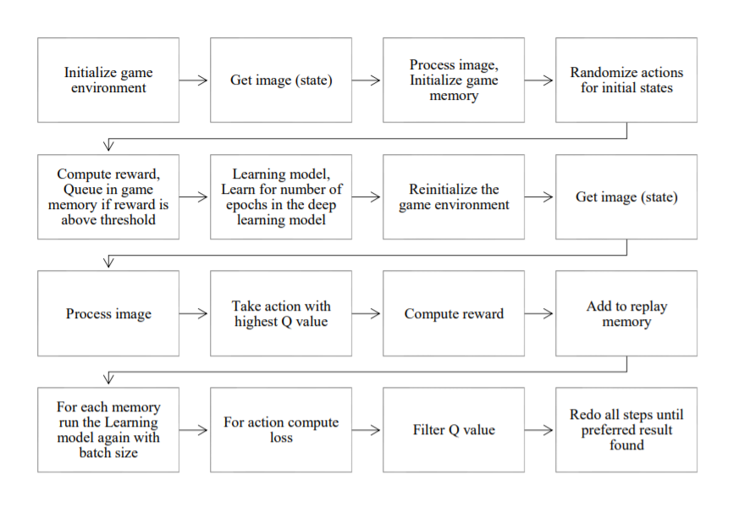

Fig.1: Flowchart of proposed Model

5.2 CREATING THE ENVIRONMENT

The first step is to create an environment for our agent to operate on. This will be implemented in a simple way using Python co- routines. The states are basically the array representation of image or some cases the game memory, for where the agent is and the opponents are. And for other cases the game environments are setup with the help of simulators and PyGame engine.

The environment consists of:
• A snake, which is a 3x1 red block when initialized,
• A food, which is a 1x1 green block,
• Four boundaries, which are 10x1 white blocks around the play area.

5.3 MODELING THE AGENT

An agent would be a model which consists of a mechanism to play the game. In this case, the agent would figure out a way to learn and play Snake. The agent uses a Convolutional Neural Network to build a DQN.

5.4 CREATING THE SNAKE GAME

For creating the game, we first display the game objects such as the snake and the fruit. Then we need to implement the game logic which describe rules of the game. First rule is that if the snake collapses with itself or with boundaries then the game ends. Second,Moving the snake to a new position. Third rule is that if the snake eats an apple, the apple moves to a new position and snake length increases.Finally, we display the score.

5.5 DEVELOPING THE NEURAL NETWORK

Developing a neural network to play a snake game usually consists of three steps.
- Training data generation
- Training neural network
- Testing

- OVERVIEW OF TECHNOLOGIES

6.1 PYTHON (PROGRAMMING LANGUAGE)
Python is a popular programming language. It was created by Guido van Rossum, and released in 1991.
It is used in:
- web development (server-side),
- software development,
- mathematics,
- system scripting.
Overview:
- Python works on different platforms (Windows, Mac, Linux, Raspberry Pi, etc).
- Python has a simple syntax similar to the English language.
- Python has syntax that allows developers to write programs with fewer lines than some other programming languages.
- Python runs on an interpreter system, meaning that code can be executed as soon as it is written. This means that prototyping can be very quick.
- Python can be treated in a procedural way, an object-orientated way or a functional way.
Applications:
- Python can be used on a server to create web applications.
- Python can be used alongside software to create workflows.
- Python can connect to database systems. It can also read and modify files.
- Python can be used to handle big data and perform complex mathematics.
- Python can be used for rapid prototyping, or for production-ready software development.

6.2 ANACONDA:

Anaconda is a free and open-source distribution of the Python and R programming languages for scientific computing (data science, machine learning applications, large-scale data processing, predictive analytics, etc.), that aims to simplify package management and deployment. Package versions are managed by the package management system conda. The Anaconda distribution is used by over 12 million users and includes more than 1400 popular data-science packages suitable for Windows, Linux, and MacOS.

Anaconda distribution comes with more than 1,400 packages as well as the Conda package and virtual environment manager, called Anaconda Navigator , so it eliminates the need to learn to install each library independently. The open source packages can be individually installed from the Anaconda repository with the conda install command or using the pip install command that is installed with Anaconda. Pip packages provide many of the features of conda packages and in most cases they can work together.

Custom packages can be made using the conda build command, and can be shared with others by uploading them to Anaconda Cloud, PyPI or other repositories. The default installation of Anaconda2 includes Python 2.7 and Anaconda3 includes Python 3.7. However, you can create new environments that include any version of Python packaged with conda .

Anaconda Navigator:
Anaconda Navigator is a desktop graphical user interface (GUI) included in Anaconda distribution that allows users to launch applications and manage conda packages, environments and channels without using command-line commands. Navigator can search for packages on Anaconda Cloud or in a local Anaconda Repository, install them in an environment, run the packages and update them. It is available for Windows, macOS and Linux.

The following applications are available by default in Navigator :

- JupyterLab
- Jupyter Notebook
- QtConsole
- Spyder
- Glueviz
- Orange
- Rstudio
- Visual Studio Code
- Conda

Main article: Conda (package manager)
Conda is an open source,cross-platform, language-agnostic package manager and environment management system that installs, runs, and updates packages and their dependencies. It was created for Python programs, but it can package and distribute software for any language (e.g., R), including multi-language projects. The Conda package and environment manager is included in all versions of Anaconda, Miniconda, and Anaconda Repository.

Anaconda Cloud
Anaconda Cloud is a package management service by Anaconda where you can find, access, store and share public and private notebooks, environments, and conda and PyPI packages. Cloud hosts useful Python packages, notebooks and environments for a wide variety of applications. You do not need to log in or to have a Cloud account, to search for public packages, download and install them.

You can build new packages using the Anaconda Client command line interface (CLI), then manually or automatically upload the packages to Cloud.

6.3 NUMPY

NumPy is a general-purpose array-processing package. It provides a high-performance multidimensional array object, and tools for working with these arrays.

It is the fundamental package for scientific computing with Python. It contains various features including these important ones:

- A powerful N-dimensional array object
- Sophisticated (broadcasting) functions
- Tools for integrating C/C++ and Fortran code
- Useful linear algebra, Fourier transform, and random number capabilities
- Besides its obvious scientific uses, NumPy can also be used as an efficient
- multi-dimensional container of generic data.
- Arbitrary data-types can be defined using Numpy which allows NumPy to seamlessly and speedily integrate with a wide variety of databases.

Installation:
- Mac and Linux users can install NumPy via pip command:
- pip install numpy
- Windows does not have any package manager analogous to that in linux or mac.
- Please download the pre-built windows installer for NumPy from here (according to your system configuration and Python version).
- And then install the packages manually.
- Note: All the examples discussed below will not run on an online IDE.

Arrays in NumPy:
NumPy’s main object is the homogeneous multidimensional array.It is a table of elements (usually numbers), all of the same type, indexed by a tuple of positive integers. In NumPy dimensions are called axes. The number of axes is rank. NumPy’s array class is called ndarray. It is also known by the alias array.

6.4 KERAS

Keras is an open-source neural-network library written in Python. It is capable of running on top of TensorFlow, Microsoft Cognitive Toolkit, Theano, or PlaidML. Designed to enable fast experimentation with deep neural networks, it focuses on being user-friendly, modular, and extensible. It was developed as part of the research effort of project ONEIROS (Open-ended Neuro-Electronic Intelligent Robot Operating System), and its primary author and maintainer is François Chollet, a Google engineer. Chollet also is the author of the XCeption deep neural network model.

Features
Keras contains numerous implementations of commonly used neural-network building blocks such as layers, objectives, activation functions, optimizers, and a host of tools to make working with image and text data easier. The code is hosted on GitHub, and community support forums include the GitHub issues page, and a Slack channel.

In addition to standard neural networks, Keras has support for convolutional and recurrent neural networks. It supports other common utility layers like dropout, batch normalization, and pooling.

Keras allows users to productize deep models on smartphones (iOS and Android), on the web, or on the Java Virtual Machine.[10] It also allows use of distributed training of deep-learning models on clusters of Graphics Processing Units (GPU) and Tensor processing units (TPU).

7. IMPLEMENTATION

7.1. SNAKE GAME WITH DEEP LEARNING

Developing a neural network to play a snake game usually consists of three steps.
- Training data generation
- Training neural network
- Testing

To do this, first, we need to develop a snake game.

7.2 CREATING A SNAKE GAME WITH PYGAME

We created a snake game with python and pygame.

What is pygame?
It is a free and open source Python programming language library used for making a multimedia application like games. It is great for beginners as it’s simple and easy to use.

Installing pygame in Python:
There are two ways to do this.

- You can directly use pip install pygame in the command window or
- Download whl file from python extension packages according to your python version.
- Then use pip install whl_file_name.

For creating a snake game using pygame library , we first need to initialize pygame modules as shown below.

Python
1 | pygame.init()

pygame.init() will attempt to initialize all the pygame modules . Not all pygame modules need to be initialized, but this will automatically initialize the ones that do.

7.2.1 Displaying Game Objects:
After initializing pygame modules, we have to display the game window. For that, we need to initialize its dimensions(width and height). Here we have used 500 x 500, which can be customized.
Python
1  2  3  4  5  6 | display_width = 500  display_height = 500  display = pygame.display.set_mode((display_width,display_height))  window_color= (200,200,200)  display.fill(window_color)  pygame.display.update()
display.fill(window_color) will fill white color into game window and pygame.display.update() allows only a portion of the screen to be updated, instead of the entire area. If no argument is passed, it updates the entire Surface area.
This will create a game window as shown below.
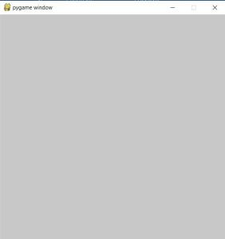
Now we have to display snake and apple. Here we have used red color for snake and an image for apple. At the start of each game, we want snake’s starting position to be fixed while apple can take any random location. Starting length of the snake is 3 units where each unit is a 10×10 block.

Python
1  2  3  4  5  6  7  8  9  10  11  12  13  14 | red = (255,0,0)  black = (0,0,0)  apple_image = pygame.image.load('apple.jpg')  snake_head = [250,250]  snake_position = [[250,250],[240,250],[230,250]]  apple_position = [random.randrange(1,50)*10,random.randrange(1,50)*10]<strong>  def display_snake(snake_position):  for position in snake_position:  pygame.draw.rect(display,red,pygame.Rect(position[0],position[1],10,10))  def display_apple(display,apple_position, apple):  display.blit(apple,(apple_position[0], apple_position[1]))  </strong>
pygame.draw.rect() will draw a rectangle corresponding to given arguments which will represent our snake and display.blit() will show the image of an apple.
This will create a game window as shown below.
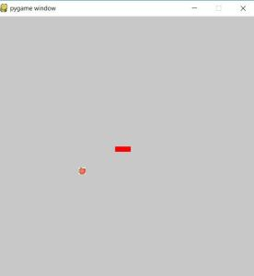
The next thing is to decide at what frame rate we want to play our game. This is done using pygame.time.Clock() that creates a “clock” object. Now whenever clock.tick() is called and passed with some number, then it will limit the run time speed of the game. As an example, if clock.tick(20) is called, then the program will never run at more than 20 frames per second.

1  2 | clock = pygame.time.Clock()  clock.tick(20)
7.2.2 Game Logic:
Now we have to define game rules since there must be some rules which makes a game playable.
Rule 1: If the snake collapses with itself or with boundaries, game over.
Python
1  2  3  4  5  6  7  8  9  10  11  12 | def collision_with_boundaries(snake_head):  if snake_head[0]>=500 or snake_head[0]<0 or snake_head[1]>=500 or snake_head[1]<0 :  return 1  else:  return 0  def collision_with_self(snake_position):  snake_head = snake_position[0]  if snake_head in snake_position[1:]:  return 1  else:  return 0
Rule 2: Moving the snake to a new position
In our game, the snake will continue to move in one direction until a button is pressed. To move the snake, we need to add one unit to the head and remove one unit from the tail.
Python
1  2 | snake_position.insert(0,list(snake_head))  snake_position.pop()
Another case is when a button is pressed to move in a direction(left, right, up or down). Also, the Snake cannot move backward.
Python
1  2  3  4  5  6  7  8  9  10  11 | if event.type == pygame.KEYDOWN:  if event.key == pygame.K_LEFT and prev_button_direction != 1:  button_direction = 0  elif event.key == pygame.K_RIGHT and prev_button_direction != 0:  button_direction = 1  elif event.key == pygame.K_UP and prev_button_direction != 2:  button_direction = 3  elif event.key == pygame.K_DOWN and prev_button_direction != 3:  button_direction = 2  else:  button_direction = button_direction

After seeing which direction button is pressed, we need to change our snakes head position.
Python
1  2  3  4  5  6  7  8  9  10  11  12  13 | if button_direction == 1:  snake_head[0] += 10  elif button_direction == 0:  snake_head[0] -= 10  elif button_direction == 2:  snake_head[1] += 10  elif button_direction == 3:  snake_head[1] -= 10  else:  pass  snake_position.insert(0,list(snake_head))  snake_position.pop()

Rule 3. If the snake eats an apple, the apple moves to a new position and snake length increases.
When the snake eats an apple, we increase our snake’s length and improve the score. To increase snake size, we add one unit at snake’s head. Also, we need to create another apple at random location to proceed the game.
Python
1  2  3  4  5  6  7  8 | def collision_with_apple(apple_position, score):  apple_position = [random.randrange(1,50)*10,random.randrange(1,50)*10]  score += 1  return apple_position, score  if snake_head == apple_position:  apple_position, score = collision_with_apple(apple_position, score)  snake_position.insert(0,list(snake_head))

7.2.3 Displaying Final Score:
After the game is over, we want to display the final score. Here, we have defined a function ‘display_final_score’, which takes final score and text to be displayed as its arguments to display in the game window.
Python
1  2  3  4  5  6  7  8 | def display_final_score(display_text, final_score):  largeText = pygame.font.Font('freesansbold.ttf',35)  TextSurf = largeText.render(display_text, True, black)  TextRect = TextSurf.get_rect()  TextRect.center = ((display_width/2),(display_height/2))  display.blit(TextSurf, TextRect)  pygame.display.update()  time.sleep(2)

This will display our final score as shown below.
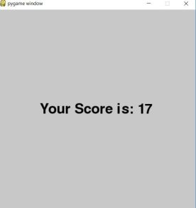.

7.3 TRAINING DATA GENERATION
Training data consists of inputs and corresponding outputs. We have used the following inputs and outputs.
Input is comprised of 7 nodes:
- Is left blocked or is there any obstacle in left ( 1 or 0)
- is front blocked or is there any obstacle in front (1 or 0)
- Is right blocked or is there any obstacle in right(1 or 0)
- Apple direction vector from snake (X)
- Apple direction vector from snake (Y)
- Snake’s current direction vector (X)
- Snake’s current direction vector (Y)
our input data will look like this:
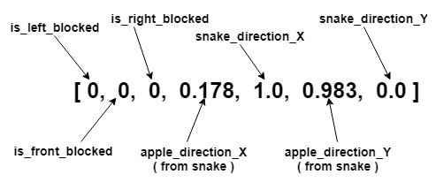

The output is comprised of 3 node:
- [1,0,0] will move snake left
- [0,1,0] will continue snake in same direction
- [0,0,1] will move snake right

Generating Training Data

We have generated training data automatically. To do this, we have used angle between snake and apple. On the basis of that angle, we have decided in which direction snake should move.

7.3.1 Calculating angle b/w snake and apple:
To calculate the angle between snake and apple we only require two parameters, snake position and apple position.
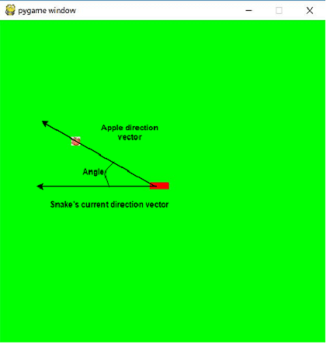
In the following code, we have first calculated the snake’s current direction vector and Apple’s direction from the snake’s current position. Snake direction vector can be calculated by simply subtracting 0th index of the snake’s list from the 1st index. And to calculate apple direction from the snake, just subtract 0th index of snake’s list from Apple’s position.
Then normalize these direction vectors and calculate the angle with the help of the math library. The code is as follows:
1  2  3  4  5  6  7  8  9  10  11  12  13  14  15 | def angle_with_apple(snake_position, apple_position):  apple_direction_vector = np.array(apple_position)-np.array(snake_position[0])  snake_direction_vector = np.array(snake_position[0])-np.array(snake_position[1])  norm_of_apple_direction_vector = np.linalg.norm(apple_direction_vector)  norm_of_snake_direction_vector = np.linalg.norm(snake_direction_vector)  if norm_of_apple_direction_vector == 0:  norm_of_apple_direction_vector = 10  if norm_of_snake_direction_vector == 0:  norm_of_snake_direction_vector = 10  apple_direction_vector_normalized = apple_direction_vector/norm_of_apple_direction_vector  snake_direction_vector_normalized = snake_direction_vector/norm_of_snake_direction_vector  angle = math.atan2(apple_direction_vector_normalized[1] * snake_direction_vector_normalized[0] - apple_direction_vector_normalized[0] * snake_direction_vector_normalized[1], apple_direction_vector_normalized[1] * snake_direction_vector_normalized[1] + apple_direction_vector_normalized[0] * snake_direction_vector_normalized[0]) / math.pi  return angle
After calculating the angle, next thing is to decide in which direction snake should move.
7.3.2 Calculating direction according to the angle:
If above-calculated angle > 0, this means Apple is on the right side of the snake. So snake should move to the right. For < 0, move left and =0 means continue in same direction. We have used 1, – 1 and 0 for the right, left and front respectively.
We used the following steps to get the correct button direction (up, down, right, left or 3, 2, 1, 0 respectively) for the next step of the snake.
- First, calculate the snake’s current direction.
- Then to turn the snake to the left or right direction, calculate left direction vector or right direction vector from snake’s current direction vector.
- Then converte the above-calculated direction vector into the button direction.

1  2  3  4  5  6  7  8  9  10  11  12  13  14  15  16  17  18  19  20  21  22  23  24  25  26  27  28  29  30  31  32  33  34  35  36 | def generate_next_direction(snake_position, angle_with_apple):  direction = 0  if angle_with_apple > 0:  direction = 1  elif angle_with_apple &lt; 0:  direction = -1  else:  direction = 0  current_direction_vector = np.array(snake_position[0])-np.array(snake_position[1])  left_direction_vector = np.array([current_direction_vector[1],-current_direction_vector[0]])  right_direction_vector = np.array([-current_direction_vector[1], current_direction_vector[0]])  new_direction = current_direction_vector  if direction == -1:  new_direction = left_direction_vector  if direction == 1:  new_direction = right_direction_vector  button_direction = generate_button_direction(new_direction)  return direction, button_direction  def generate_button_direction(new_direction):  button_direction = 0  if new_direction.tolist() == [10,0]:  button_direction = 1  elif new_direction.tolist() == [-10,0]:  button_direction = 0  elif new_direction.tolist() == [0,10]:  button_direction = 2  else:  button_direction = 3  return button_direction
Now, for every step, angle and corresponding next direction are calculated and snake moves according to that. And for each step inputs and outputs are calculated which are appended to a list of training data.To generate training data, we need to keep a record of 7 inputs and 3 outputs for every step the snake takes.
- To check if the direction is blocked, we look one step ahead in each direction.
- Snake direction vector = Snake’s Head (0th index) – Snake’s 1st index
- Apple direction from the snake = Apple’s position – Snake’s head position
For every step, the output is generated by first calculating the direction for the given snake and apple position, using angle between them. Now, we need to convert our directions( -1, 0 or 1 ) to output(Y), a one hot vector. For every predicted direction we need to see that if that direction is blocked or not and according to that create output (Y) for training data. The code given below seems to be a bit longer but it calculates our training data output (Y).

1  2  3  4  5  6  7  8  9  10  11  12  13  14  15  16  17  18  19  20  21  22  23  24  25  26  27  28  29  30  31  32  33  34  35  36  37  38  39  40  41  42  43  44 | def generate_training_data_y(snake_position, angle_with_apple, button_direction, direction, training_data_y, is_front_blocked, is_left_blocked ,is_right_blocked):  if direction == -1:  if is_left_blocked == 1:  if is_front_blocked == 1 and is_right_blocked == 0:  direction, button_direction = direction_vector(snake_position, angle_with_apple, 1)  training_data_y.append([0,0,1])  elif is_front_blocked == 0 and is_right_blocked == 1:  direction, button_direction = direction_vector(snake_position, angle_with_apple, 0)  training_data_y.append([0,1,0])  elif is_front_blocked == 0 and is_right_blocked == 0:  direction, button_direction = direction_vector(snake_position, angle_with_apple, 1)  training_data_y.append([0,0,1])  else:  training_data_y.append([1,0,0])  elif direction == 0:  if is_front_blocked == 1:  if is_left_blocked == 1 and is_right_blocked == 0:  direction, button_direction = direction_vector(snake_position, angle_with_apple, 1)  training_data_y.append([0,0,1])  elif is_left_blocked == 0 and is_right_blocked == 1:  direction, button_direction = direction_vector(snake_position, angle_with_apple, -1)  training_data_y.append([1,0,0])  elif is_left_blocked == 0 and is_right_blocked == 0:  training_data_y.append([0,0,1])  direction, button_direction = direction_vector(snake_position, angle_with_apple, 1)  else:  training_data_y.append([0,1,0])  else:  if is_right_blocked == 1:  if is_left_blocked == 1 and is_front_blocked == 0:  direction, button_direction = direction_vector(snake_position, angle_with_apple, 0)  training_data_y.append([0,1,0])  elif is_left_blocked == 0 and is_front_blocked == 1:  direction, button_direction = direction_vector(snake_position, angle_with_apple, -1)  training_data_y.append([1,0,0])  elif is_left_blocked == 0 and is_front_blocked == 0:  direction, button_direction = direction_vector(snake_position, angle_with_apple, -1)  training_data_y.append([1,0,0])  else:  training_data_y.append([0,0,1])  return direction, button_direction, training_data_y

Here, we have used 1000 games for generating training data, each of which consists of 2000 steps. For every game, we have re-initialized snake position, apple position, and score. Then, created two empty lists, one for input training data(X) and another output training data(Y), those will contain our whole training data.The code is as follows:

1  2  3  4  5  6  7  8  9  10  11  12  13  14  15  16  17  18  19  20  21  22  23  24  25  26  27  28  29  30  31 | def generate_training_data(display,clock):  training_data_x = []  training_data_y = []  training_games = 1000  steps_per_game = 2000  for _ in tqdm(range(training_games)):  snake_start, snake_position, apple_position, score = starting_positions()  prev_apple_distance = apple_distance_from_snake(apple_position, snake_position)  for _ in range(steps_per_game):  angle, snake_direction_vector, apple_direction_vector_normalized, snake_direction_vector_normalized = angle_with_apple(snake_position, apple_position)  direction, button_direction = generate_random_direction(snake_position, angle)  current_direction_vector, is_front_blocked, is_left_blocked ,is_right_blocked = blocked_directions(snake_position)  direction, button_direction, training_data_y = generate_training_data_y(snake_position, angle_with_apple, button_direction, direction, training_data_y, is_front_blocked, is_left_blocked ,is_right_blocked)  if is_front_blocked == 1 and is_left_blocked == 1 and is_right_blocked == 1:  break  training_data_x.append([is_left_blocked, is_front_blocked, is_right_blocked,apple_direction_vector_normalized[0], \  snake_direction_vector_normalized[0], apple_direction_vector_normalized[1], \  snake_direction_vector_normalized[1]])  snake_position, apple_position, score = play_game(snake_start, snake_position, apple_position, button_direction, score,display,clock)  return training_data_x, training_data_y

7.4 TRAINING AND TESTING THE NEURAL NETWORK

This is the second part of the snake game with deep learning. In this section, training and testing of the neural network from generated training data is discussed.

Our neural network is comprised of 7 nodes in the input layer, 3 node in the final layer and some hidden layers.
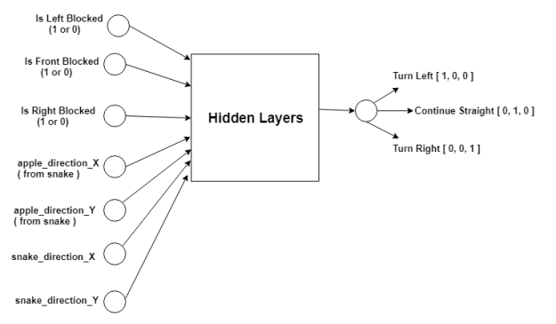

Network Architecture:
Now, we to choose hidden layers and corresponding hyperparameters. Its always been difficult to find the perfect neural network architecture. There are some algorithms that can help to find the best network architecture for a neural network like a genetic algorithm, NAS, autoML etc.

We have used hit and trial method to find network architecture. After some hit and trials, we have found a workable architecture, which consists of 2 hidden layers one of 9 units and other of 15 units. For the hidden layer, we have used the non-linear function ‘relu’ and for the output layer, we have used ‘softmax’.
Different libraries can be used to train this model like keras, tflearn, etc. Here, we have used keras. Our network architecture is as follows:

1  2  3  4  5 | model = Sequential()  model.add(Dense(units=9,input_dim=7))  model.add(Dense(units=15, activation='relu'))  model.add(Dense(output_dim=3, activation = 'softmax'))

7.4.1 Train Neural Network

For training, we first need to compile this model then call a method model.fit() which will do the rest. Since our training data is a list, we first need to change it into numpy array and then reshape it. The reason for this is, a sequential model from keras expects numpy array or sparse matrix of shape [n_samples,n_features].

1  2 | model.compile(loss='mean_squared_error', optimizer='adam', metrics=['accuracy'])  model.fit((np.array(training_data_x).reshape(-1,7)),(np.array(training_data_y).reshape(1,3)), batch_size = 256,epochs= 3)

7.4.2 Test Snake Game

To predict the direction, we have fed our model with input values. Then used the predicted direction(Left, Straight or Front) to take the next step in our test games. For the new position, again predict the direction and move the snake. This continues until the snake dies or steps are over.
At last, we have calculated the maximum and average score for all the games in our test set.

1  2  3  4  5  6  7  8  9  10  11  12  13  14  15  16  17  18  19  20  21  22  23  24  25  26  27  28  29  30  31  32  33  34  35  36  37  38  39  40  41  42  43  44  45  46  47  48  49 | def run_game_with_ML(model,display,clock):  max_score = 3  avg_score = 0  test_games = 1000  steps_per_game = 2000  for _ in range(test_games):  snake_start, snake_position, apple_position, score = starting_positions()  count_same_direction = 0  prev_direction = 0  for _ in range(steps_per_game):  current_direction_vector, is_front_blocked, is_left_blocked ,is_right_blocked = blocked_directions(snake_position)  angle, snake_direction_vector, apple_direction_vector_normalized, snake_direction_vector_normalized = angle_with_apple(snake_position, apple_position)  predictions = []  predicted_direction = np.argmax(np.array(model.predict(np.array([is_left_blocked, is_front_blocked, \  is_right_blocked,apple_direction_vector_normalized[0], \  snake_direction_vector_normalized[0], apple_direction_vector_normalized[1], \  snake_direction_vector_normalized[1]]).reshape(-1,7))))-1  if predicted_direction == prev_direction:  count_same_direction+=1  else:  count_same_direction = 0  prev_direction = predicted_direction  new_direction = np.array(snake_position[0]) - np.array(snake_position[1])  if predicted_direction == -1:  new_direction = np.array([new_direction[1],-new_direction[0]])  if predicted_direction == 1:  new_direction = np.array([-new_direction[1],new_direction[0]])  button_direction = generate_button_direction(new_direction)  next_step = snake_position[0]+ current_direction_vector  if collision_with_boundaries(snake_position[0]) == 1 or collision_with_self(next_step.tolist(), snake_position) == 1:  break  snake_position, apple_position, score = play_game(snake_start, snake_position, apple_position, button_direction, score,display,clock)  if score > max_score:  max_score = score  avg_score += score  return max_score, avg_score/1000

8.RESULTS AND DISCUSSIONS

We have used 1000 training games and 2000 steps per game. From this, we have generated 1633235 training examples. Then we tested it on 1000 games and 2000 steps per game. Got the highest score of 71 and got an average score of 23.091. This score can vary since we are using random positions for food and also no of steps are fixed. Clock speed can be varied as per need.

The image below represents the screenshot of the game when highest score was achieved during the 332nd game. The score keeps fluctuating as the agent learns to improve itself.

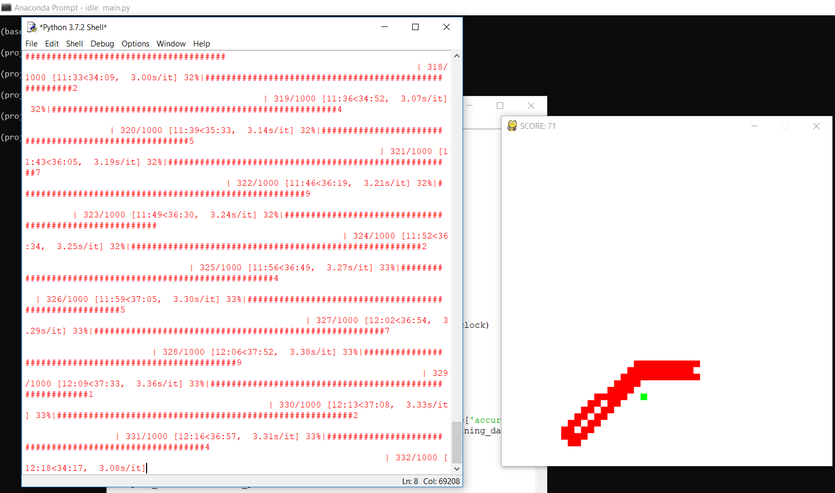

9. CONCLUSION ANF FUTURE SCOPE

9.1 CONCLUSION

In this report, we presented a model to solve 2D games with Deep reinforcement learning approach. We introduced a new deep learning model to play game like snake using raw pixels for input and also the provided framework by PyGame. We also presented trial and error implementation method for finding satisfied model for playing the game. We used deep reinforcement learning for finding better results.

9.2 FUTURE SCOPE

We have now the idea of neural network for working with 2D games. In future we are planning to work with 3D games and the online ones like Dota2 or PUBG. In these environments we have to consider many aspects and features and there we may need to optimize each action in batches, like moving can be a batch of actions which will depend on seeing the objects or enemies, firing or attacking and other strategies a human player consider can also be taught to the agent. We also intend to implement genetic algorithm for even better learning and accuracy. Ultimately, try to create an agent that can be used to play against humans in two player and multi player games.

- REFERENCES

- En.wikipedia.org. (2017). Q-learning. [online] Available at: https://en.wikipedia.org/wiki/Qlearning [Accessed 13 Dec. 2017].
.
- Science, L. (2017). The Spooky Secret Behind Artificial Intelligence's Incredible Power. Live Science. Available at: https://www.livescience.com/56415-neural-networks-mimicthe-laws-of-physics.html

- D. Takahashi, "PwC: Game industry to grow nearly 5% annually through 2020", VentureBeat, 2017. [Online]. Available: https://venturebeat.com/2016/06/08/the-u-s-and-global-game-industrie s-will-grow-a-healthy-amount-by-2020-pwc-forecasts/.

- "A Brief History of Computing", Alanturing.net, 2017. [Online]. Available: http:// www.alanturing.net/.

- P. McCorduck, Machines who think. Natick, Mass: A.K. Peters, 2004.

- "Artificial Intelligence in Game Design", Ai-depot.com, 2017. [Online]. Available: http://aidepot.com/GameAI/Design.html.

- "Mario AI Competition 2009", Julian.togelius.com, 2017. [Online]. Available: http://julian.togelius.com/mariocompetition2009/.

- "Artificial intelligence learns Mario level in just 34 attempts", Engadget, 2017. [Online]. Available:https://www.engadget.com/2015/06/17/super-mario-world-self-learning-ai/.

- Schmidhuber, J., 2015. Deep learning in neural networks: An overview. Neural networks, 61, pp.85-117.

- Sutskever, I., Vinyals, O. and Le, Q.V., 2014. Sequence to sequence learning with neural networks. In Advances in neural information processing systems (pp. 3104-3112).

- Le, Q.V., Ngiam, J., Coates, A., Lahiri, A., Prochnow, B. and Ng, A.Y., 2011, June. On optimization methods for deep learning. In Proceedings of the 28th International Conference on International Conference on Machine Learning (pp. 265-272). Omnipress.

- Simonyan, K. and Zisserman, A., 2014. Very deep convolutional networks for large-scale image recognition. arXiv preprint arXiv:1409.1556.

- Hausknecht, M. and Stone, P., 2015. Deep recurrent q-learning for partially observable mdps. CoRR, abs/1507.06527.

- Van Hasselt, H., Guez, A. and Silver, D., 2016, February. Deep Reinforcement Learning with Double Q-Learning. In AAAI (pp. 2094-2100). Page 47 of 47

- Mnih, V., Kavukcuoglu, K., Silver, D., Rusu, A.A., Veness, J., Bellemare, M.G., Graves, A., Riedmiller, M., Fidjeland, A.K., Ostrovski, G. and Petersen, S., 2015. Human-level control through deep reinforcement learning. Nature, 518(7540), pp.529-533.

- "Guest Post (Part I): Demystifying Deep Reinforcement Learning - Intel Nervana", Intel Nervana, 2017. [Online]. Available: https://www.intelnervana.com/demystifying-deepreinforcement-learning/.

